# Website Design

## Inspirational Websites:

I am taking these three websites for inspirations towards my own design:

Mannys Music:

[https://www.mannys.com.au](https://www.mannys.com.au/?gclid=Cj0KCQjwhb36BRCfARIsAKcXh6F1PUTKiq5Vs8pUtQkfhZ0SpcWRMaOALJqfqXzfNA2XyHO7axpbAX0aAlteEALw_wcB)/

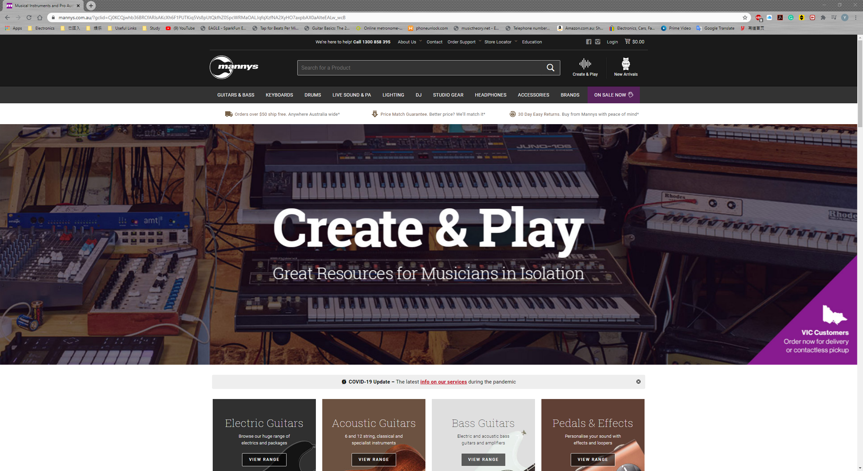

Bookings:

[https://www.booking.com](https://www.booking.com/index.en-gb.html?aid=376367;label=booking-name-c8fIkCExjSRUy2uljpllUgS267725016198%3Apl%3Ata%3Ap1%3Ap22%2C563%2C000%3Aac%3Aap%3Aneg%3Afi%3Atikwd-65526620%3Alp9071448%3Ali%3Adec%3Adm%3Appccp%3DUmFuZG9tSVYkc2RlIyh9YSMvrW9srej9dwl-lxl_KWY;sid=d6d2c64156a7f4307797cf3088cc51af;lang=en-gb;sb_price_type=total;soz=1&)/

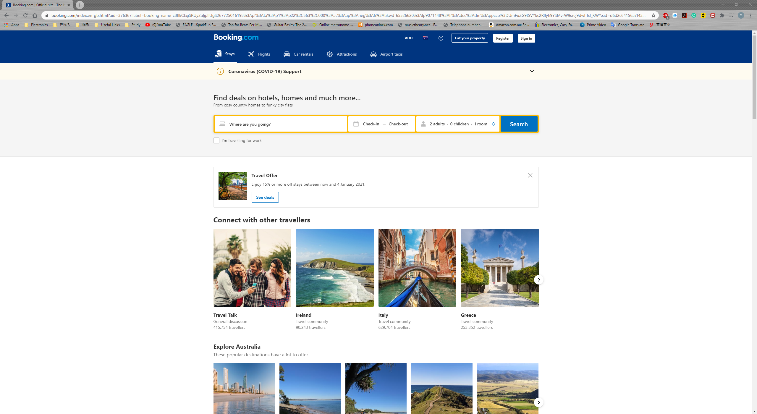

Peter Stevens Motorcycle:

[https://www.peterstevens.com.au/](https://www.peterstevens.com.au/?gclid=Cj0KCQjwhb36BRCfARIsAKcXh6Ge-BGkUhJ-rpKwFag4VdEnyK9-9wQFxN6S2ENcpKKt7M4N5QABPggaAo9EEALw_wcB)

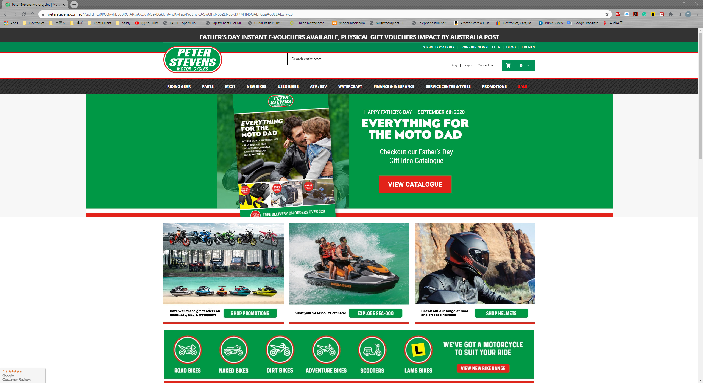

These websites are for retail and service business, therefore feature wise, all of them emphasize their searching feature by putting the search box at the top of the page, which users will feel convenient. In terms of layout, they put the navigation bar at the similar and familiar spot, so users can easily identify it which I believe that I should also follow in my own design as this is intuitive and conventional for most users. They also neatly arrange all the images, so they look organised and appealing. As for the style, all these websites put their logos and brandings right at the top, which makes it outstanding and all these sites have their own distinguishing theme colour that represents their business. This gives the users an impression that the business is genuine and the web page is professionally designed.

## Site Map:

## Wireframe:

